**Function & Return Keyword**

**Declaring a Function**

syntax :

function nameOfFunction () {

// function body

}

**Calling a Function**

<html>

    <body>

        <h2>Function & Return Keyword</h2>

        <script>

function abc() {

    console.log("Hello there");

}

      abc();

        </script>

    </body>

</html>

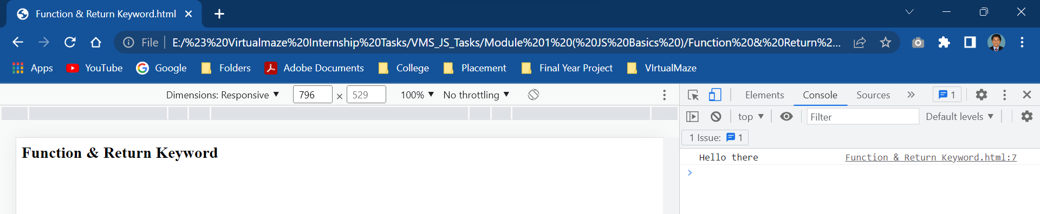

**Function Parameters**

A function can also be declared with parameters. A parameter is a value that is passed when declaring a function.

<html>

    <body>

        <h2>Function & Return Keyword</h2>

        <script>

function abc(name) {

    console.log("Hello " + name + "!!!");

}

let name = prompt("Enter a name: ");

abc(name);

        </script>

    </body>

</html>

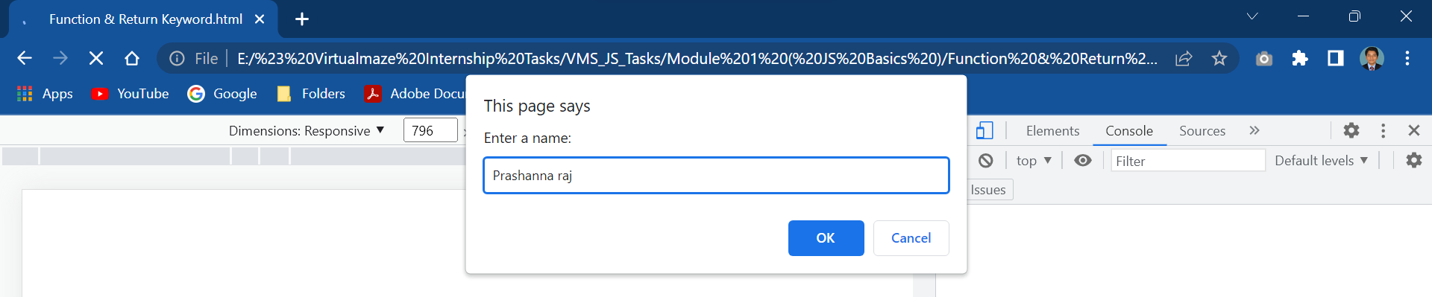

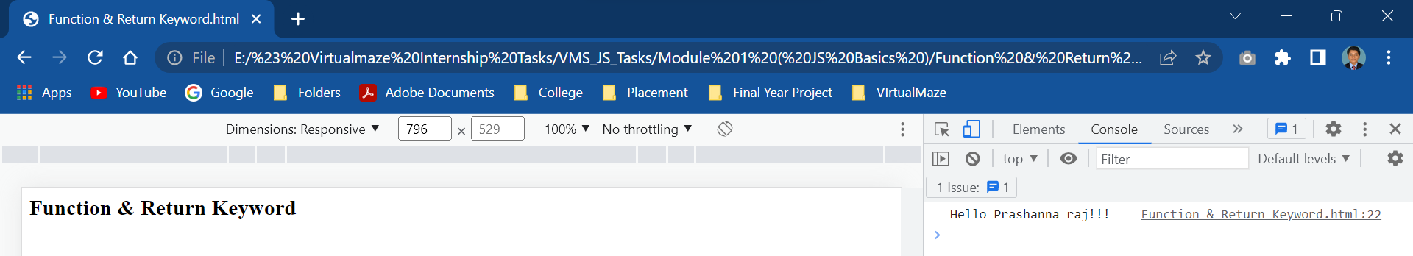

Function Return

<html>

<body>

<h2>Function & Return Keyword</h2>

    <script>

var res = fun(12, 30);

function fun(x, y)

{

return x * y;

}

document.write(res);

console.log(res);

    </script>

</body>

</html>